CIBA Resolution Standard
Resolution standards are essential for calibrating and characterising the spatial resolution and scan dimensions of imaging systems. These standards enable precise determination of minimum resolvable distance, scan field dimensions, and beam spot size, particularly those employing charged particles like protons and electrons. For proton and electron beam imaging, requirements include high spatial resolution, precise beam spot size measurement, and low uncertainty in scan size calibration.
In 2013, Yao et al. [1] demonstrated via simulation that proton beam lithography can achieve resolution standards with remarkably vertical side walls (89.7°) in 500 nm thick nickel, utilising poly-methyl methacrylate (PMMA) resist material. This feat is unattainable with electron beam lithography due to significant electron straggling in PMMA, resulting in large side wall gradients. In contrast, protons – 1836 times heavier than electrons – travel largely undeflected through the medium, enabling the creation of straight side walls.
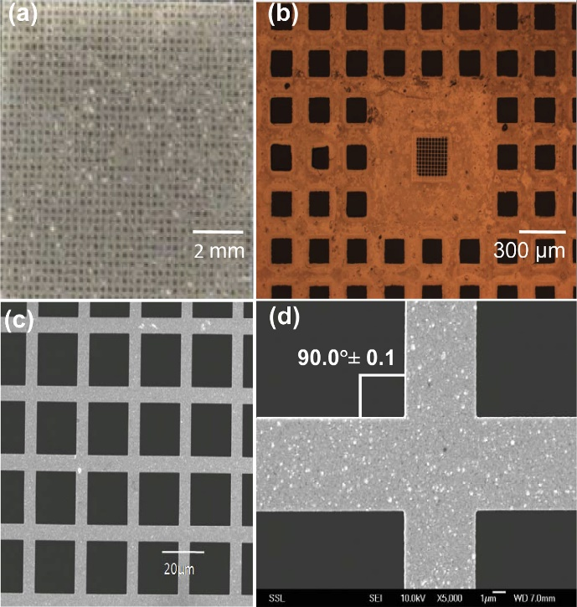
CIBA’s state-of-the-art accelerator drives our pioneering proton beam writing (PBW) system, which has yielded an array of achievements. These include significant biological applications [2] and the attainment of record-breaking spot sizes [3].
Utilising the same advanced proton beam writing (PBW) system, we can produce high-precision resolution standards featuring fine grids. A notable example is the nickel grid fabricated by Yao et al. [1], shown in Figure 1, which demonstrates the system’s exceptional capabilities.
Figure 1: Optical micrographs (a, b) and SEM images
(c, d) of fabricated nickel resolution standard
(Obtained from Yao et al. [1])
Further simulations reveal that our PBW system can achieve resolution standards with remarkably vertical side walls, reaching an unprecedented 89.8° - 89.9°. This exceeds the industry standard for straight side walls by an order of magnitude, enhancing the reliability and accuracy of characterisation results.
Grid vs Spherical Resolution Standards
In the market, spherical resolution standards such as near-perfect round tin spheres are used to characterise the imaging resolution. They vary in sizes ranging from few nanometres to a few hundred nanometres. Resolution of the imaging system using such standards is determined by one of three methods: edge definition, point spread function of the sphere treated as a point object, and the gap separation test.
For the first method, edges of the spheres are scanned, and the resulting line profile is fitted with a mathematical function that provides the resolution as an optimised parameter. This approach relies on the curvature of the side of the sphere. A grid with straight side walls may perform better and give more accurate results due to it eliminating any errors contributed by this curvature of the sphere.
The second method scans the sphere, assuming it to be a point object. The full-width-half-maximum (FWHM) of the resulting processed gaussian profile of the image would give the resolution of the imaging system. However, this approach relies heavily on the actual physical dimensions of the sphere, whereas the grid completely overcomes this limitation by utilising the edge straightness for the same purpose.
The third method requires finding a gap between two spheres that reside very closely with each other. If the imaging system can clearly distinguish the gaps between them, the distance measured by the imaging system would be the resolution. However, this has the same issue as the second method, since the gaps are not the same between any two spheres. The best measured resolution is hence directly dependant on the physical gap separation.
These conclusions point to the potential our grids could have over commercial spherical resolution standards.

